Q1. Website Specifications
a. Website Objective & Goals
The proposed website is for a company called HiTech Motors, a business that sells new and used vehicles.
Objective:
The main objective of the website is to provide an online platform where customers can browse available cars, get detailed vehicle information, and contact the company for purchases or inquiries.
Goals:
- Increase business visibility online
- Allow customers to browse and select vehicles easily
- Provide detailed information about available cars (price, model, specifications)
- Enable customers to make inquiries or book test drives
- Build trust through a professional and modern website

b. Target Audience
The target audience includes:
Demographics:
- Age: 21 – 60 years
- Location: Urban and semi-urban areas (e.g., Gaborone)
- Occupation: Working professionals, business owners, families
Technical Aptitude:
- Basic to intermediate internet skills
- Able to browse websites and compare products
- Use smartphones and computers regularly

c. Type of Website
The website will be a:
Business / E-commerce (Car Sales) Website
Content includes:
- Car listings (new and used vehicles)
- Vehicle details (price, mileage, specifications)
- About the company
- Contact and inquiry form
- Test drive booking option

Q2. Information Design & Taxonomy
Information Architecture (Site Structure)
The website will have the following pages:
- Home
- Cars / Inventory
- Car Details
- About Us
- Contact Us
Navigation Structure
- A top navigation bar will be used on all pages
- Users can access any page within 3 clicks (3-click rule)
- Footer will include quick links and contact details
Storyboard / Flow
- User lands on Home Page
- Navigates to Cars / Inventory
- Selects a vehicle to view details
- Clicks Contact or Book Test Drive

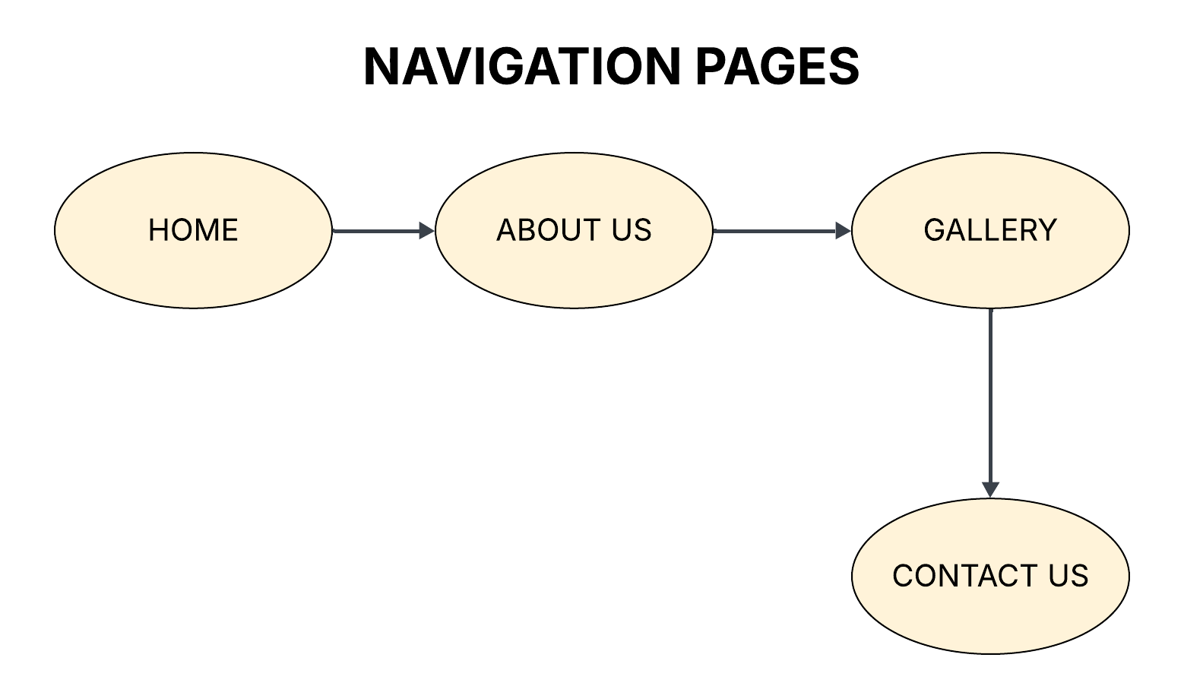
Q3. Page Template Design
Wireframe Description (Layout of Pages)
Each page will follow a consistent structure:
- Header (Logo + Navigation Menu)
- Main Content Area (Car listings or details)
- Sidebar (optional filters like price, brand, etc.)
- Footer (contact info, links, social media)

Design Features
- Clean and modern layout
- Consistent colors (black, white, red or blue for automotive feel)
- High-quality images of cars
- Clear sections with proper spacing
- Responsive design (mobile & desktop friendly)

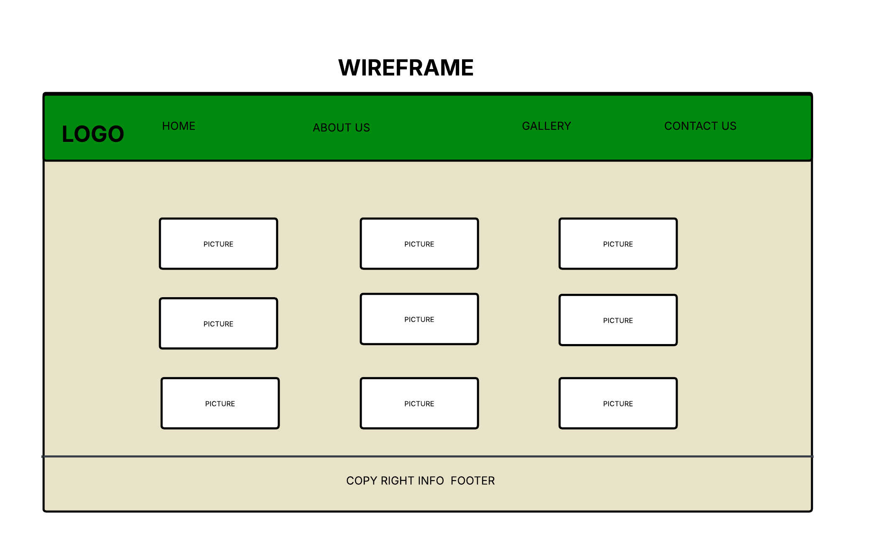
Q4. Technical Brief
Technologies to be Used
Frontend Development:
- HTML5 – structure of pages
- CSS3 – styling and layout
- JavaScript – interactivity (car filters, image sliders)

Frameworks & Tools
- Bootstrap – responsive design
- Visual Studio Code – code editor
- GitHub – version control and hosting
- GitHub Pages – publishing website

Graphics & Design Tools
- Canva / GIMP – create logos and banners
- Google Fonts – typography

